**Bug Finding & Reporting**

* **Bug ID:** 001
* **Title:** The first letter of the Referral code error message is small and exclamation mark at the end of the sentence.
* **Environment:** Web App
* **Steps to Reproduce:**1. Navigate to Scopex home page  
  2. Click on the Register button  
  3. Enter valid Name of the user  
  4. Enter valid Email Address  
  5. Enter incorrect Referral code  
  6. Click Signup button
* **Expected Result:** The error message should appear saying “Referral code is incorrect!”
* **Actual Result:** The error message should be “Referral code is incorrect.”
* **Screenshot:**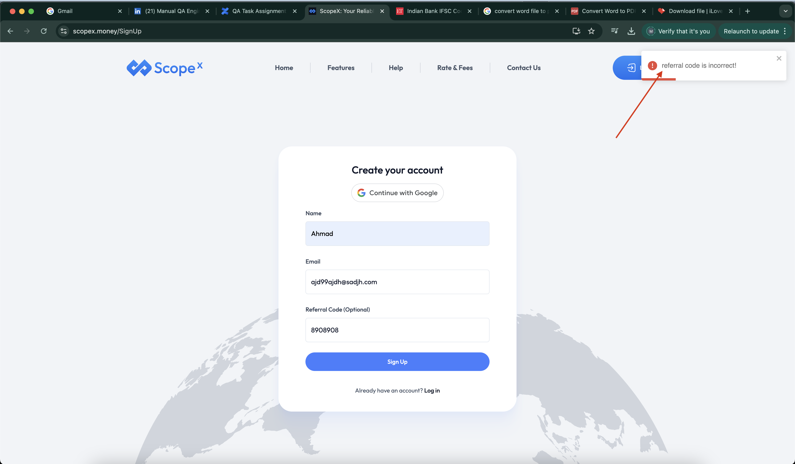
* **Severity:** Low
* **Bug ID:** 002
* **Title:** The filter for the month on the Analytics section should say Last 3 months, Last 6 months and Last 12 months
* **Environment**: Web App, Mobile App
* **Steps to Reproduce:**1. Navigate to Scopex home page  
  2. Click on the Login button  
  3. Enter valid Name of the user  
  4. Enter valid Email Address  
  6. Click on Login button   
  7. Navigate to the Analytics section on Dashboard
* **Expected Result:** The filter for the month on the Analytics section should say Last 3 months, Last 6 months and Last 12 months.
* **Actual Result:** The filter for the month on the Analytics section says 3 months, 6 months and 12 months. It creates confusion for the user as to which months are being referred here
* **Screenshot:**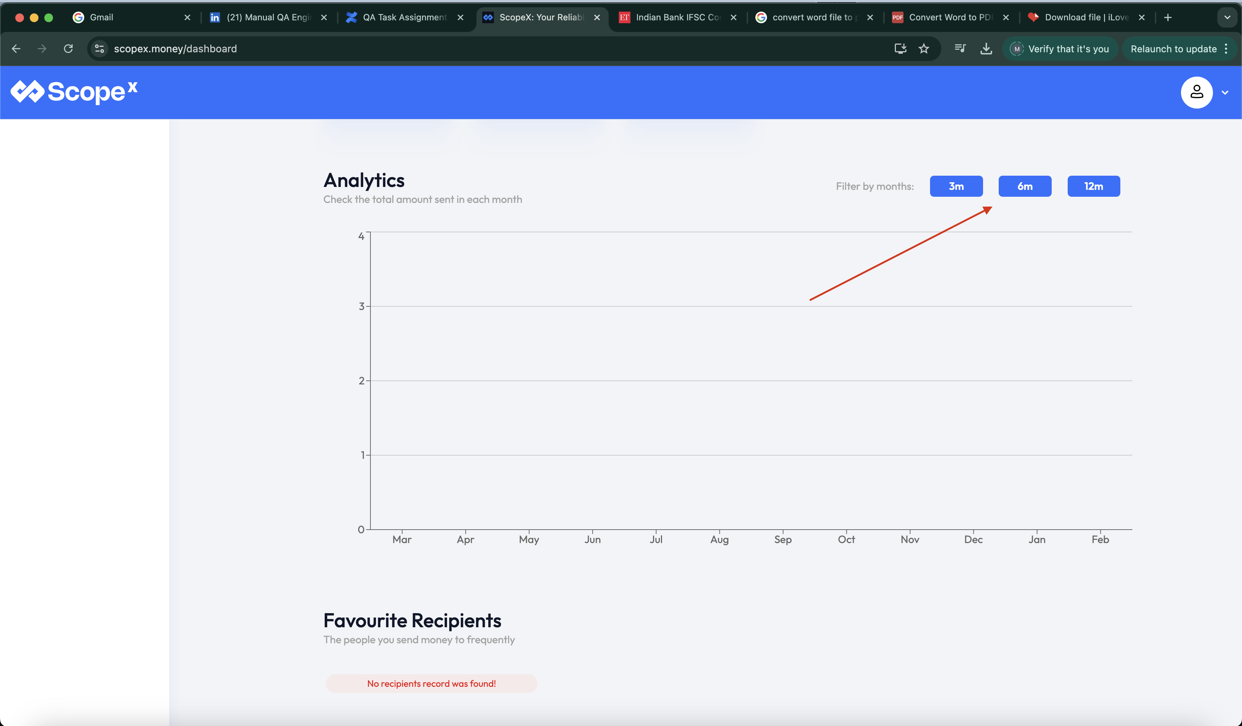
* **Severity:** Low

* **Bug ID:** 003
* **Title:** Clicking on the Scopex logo on the sidebar takes the user back to the homepage.
* **Environment:** Web App
* **Steps to Reproduce:**1. Navigate to Scopex home page  
  2. Click on the Login button  
  3. Enter valid Name of the user  
  4. Enter valid Email Address  
  5. Click on Login button  
  6. Click on Transfer History or any other option on the sidebar to move away from the Dashboard   
  7. Click on the Scopex logo on the sidebar
* **Expected Result:** By clicking on the Scopex log on the sidebar user is navigated back to the home page.
* **Actual Result:** If user clicks on the Scopex Logo the user should be taken to the Dashboard instead of the home page.
* **Screenshot:**

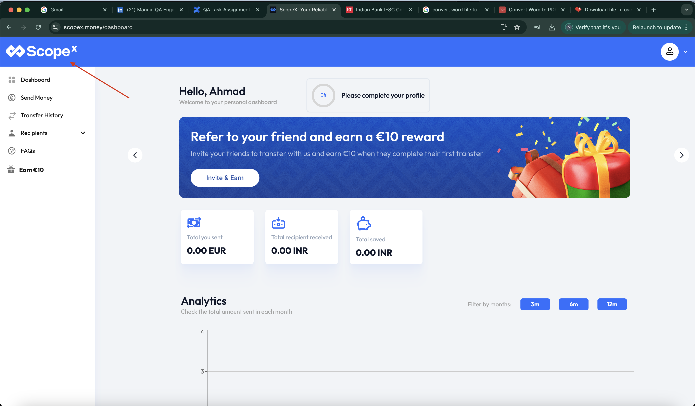

* **Severity:** Medium
* **Bug ID:** 004
* **Title:** For the Send Amount the field should be restricted to the max number that can be entered
* **Environment**: Web App, Mobile App
* **Steps to Reproduce:**1. Navigate to Scopex home page  
  2. Click on the Login button  
  3. Enter valid Name of the user  
  4. Enter valid Email Address  
  6. Click on Login button   
  7. Navigate to the Send Money section and type the following number in the Send amount field : 234234234243243
* **Expected Result:** The field shouldn’t allow the user to enter a number greater than the maximum number allowed and only one error message should be shown instead of showing error message on every number entered above the max limit.
* **Actual Result:** The user can enter as many digits as he wants and the application shows error message upon entering every number above the max limit.
* **Screenshot:**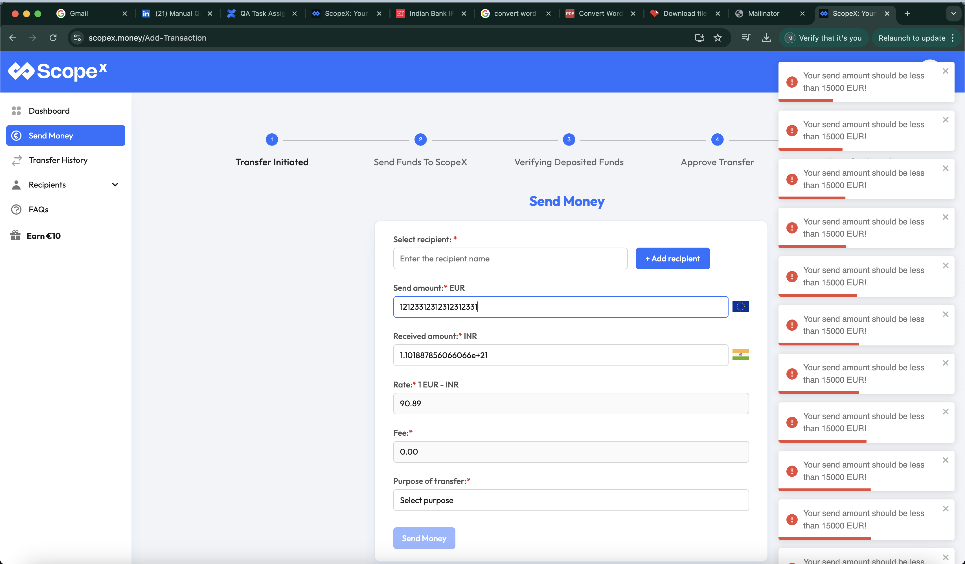
* **Severity:** Medium
* **Bug ID:** 005
* **Title:** The bank account number field shouldn’t allow alphabets.
* **Environment**: Web App, Mobile App
* **Steps to Reproduce:**1. Navigate to Scopex home page  
  2. Click on the Login button  
  3. Enter valid Name of the user  
  4. Enter valid Email Address  
  6. Click on Login button   
  7. Navigate to the Add Recipient section  
  8. Enter alphabets in the bank account number field
* **Expected Result:** The field shouldn’t allow the alphabets and only one error message should be shown instead of showing error message on every alphabet typed in the field.
* **Actual Result:** The user can enter alphabets in the bank account number field and application shows error message upon entering every alphabet in the field.
* **Screenshot:**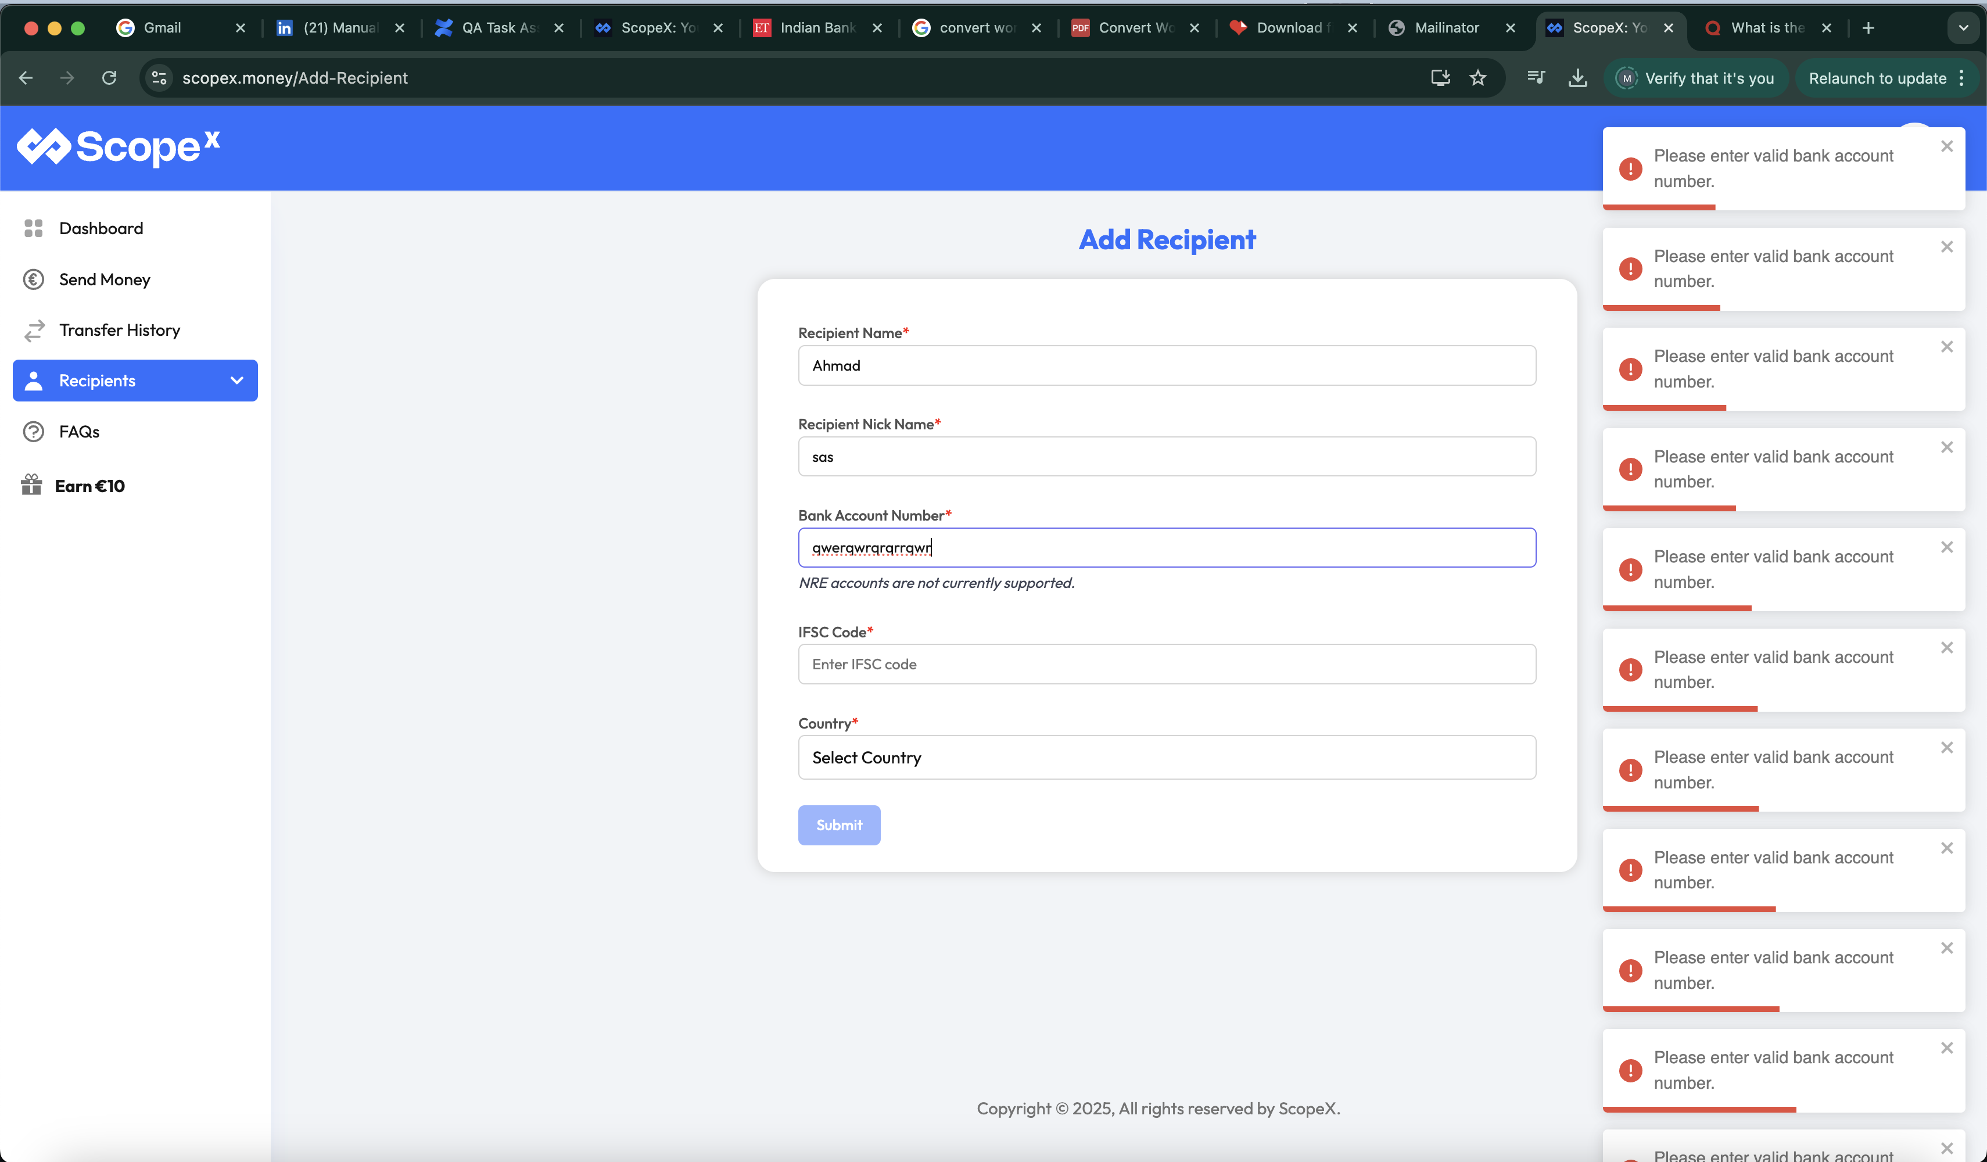

**Severity:** Medium